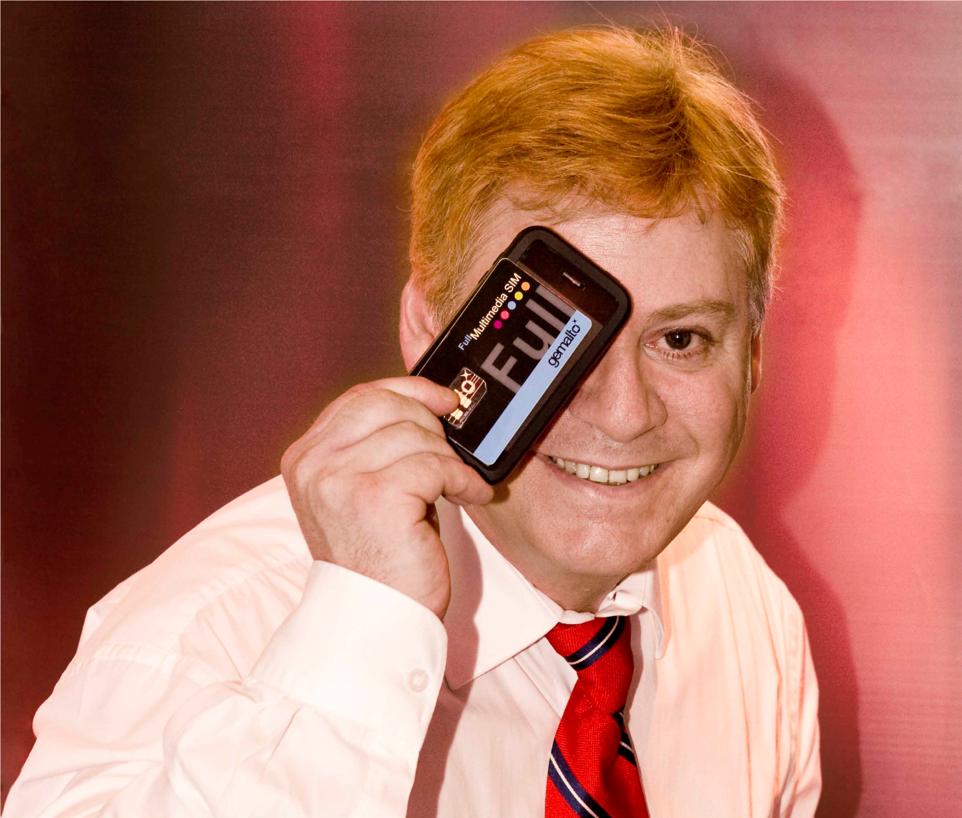

Karl J. Weaver 魏卡爾
Gemalto’s Greater China Mobile NFC Payments Country Manager
He paved the way with more than 200 public speaking presentations for Gemalto since 2008 to achieve mobile payments and device security in Greater China.

The Smartphone Public Speaking Rainmaker Karl J. Weaver魏卡爾
**Reporter:** Zhang Feng / **Text:** Liu Li-Jie / **Photography:** A translation from the original in China Financial Commerce Magazine of October 2010

This blonde American, fluent in Mandarin Chinese, delivers passionate speeches at nearly every forum and conference related to mobile payments digital technology, the internet, and investment in Beijing, Shanghai, Shenzhen, and Hong Kong.
It's not just talk. He represents Gemalto, a French smart SIM card manufacturer. "Our technology embeds NFC (Near Field Communication) technology into standard uSIM cards, allowing users to enjoy convenient contactless mobile payment methods through OTA (Over-The-Air) downloads," Karl explains. He then offers a more relatable analogy—"It's like sticking a multi-purpose card onto your phone, but with more functions."
Gemalto aims to promote this in major Chinese cities, but it's no easy task. Mobile payments, like the rollout of 3G phones, require special phones and uSIM cards. This means mobile service providers need to place custom orders with phone manufacturers. Moreover, the support of major banks and China UnionPay is essential as it involves personal accounts.

Karl believes that to widely adopt mobile payment (contactless mobile payment) technology in China, delivering public speeches are the best tool. In May 2008, Karl joined Gemalto’s Beijing office as the Mobile Business Development Manager. His arrival marked a turning point for the previously stalled mobile payment technology in China.
An American with a Taiwanese Accent
Born in Quincy, Massachusetts, Karl earned his Bachelor of Science degree from Salve Regina University in Newport, Rhode Island in 1982. Afterward, he received a scholarship to study Mandarin Chinese Language in Taiwan at National Taiwan Normal University’s Mandarin Training Center, where he studied and worked for 10 years. He first spent three years studying Chinese and then worked at Digicom in Taiwan for seven years as Export Sales Manager.
During this time, he married a Taiwanese woman, who is now a US Citizen with a Junior High School-aged daughter who can also speak Mandarin, like her Dad, Karl had become fluent in Chinese, albeit with a slight Taiwanese accent.
"In the 1980s, it was quite rare for a foreigner to chat and do business in Chinese," Karl recalls. This proficiency became a significant credential on his resume, leading to frequent assignments in Asia-Pacific market development roles after he returned to the U.S. in 1992.
"I feel more suited to working in Greater China and I like it here," Karl says. He feels fortunate that whenever he wants to return to Greater China, opportunities always arise, whether being in Taiwan, Hong Kong, or Beijing.
After returning to the U.S. from Taiwan in late 1992, Karl continued to work in wireless technology, including mobile hardware, software, and operating systems.
Karl has a passion, which is also his career. He loves to deliver mobile technology public speaking and believes he has a natural talent for making technical topics understandable.
The Speaking Journey
Since late 2002, Karl has delivered over 200 public speaking presentations and been interviewed at seminars, trade shows, and forums on smartphones, integrated mobile devices, 3G Broadband wireless, and “The Subtle Art of Doing Business” in China and India. During this assignment to Beijing in 2008, Gemalto, a famous French Smartcard manufacturer, was struggling in the Chinese market for mobile payment uSIMs to find mobile handset partnerships.

The complicated relationships among China Mobile, China Unicom, and China Telecom made it tough for foreign companies to navigate these rough waters. They decided to enlist the help of this American who speaks fluent Mandarin Chinese Languages, is an expert in Smartphone mobile technologies, and understands Chinese customs to promote Contactless mobile NFC payments in China.
"When my assistant first saw me at work, they found it odd and thought, 'This foreigner seems to understand Chinese business better than me,'" Karl’s assistant recalls. Many others were eager to see how this so-called China expert would open up the market for Gemalto.
Doing It the Chinese Way
"Implementing mobile payment is a complex supply-chain related process, requiring at least 20% of phone OEM manufacturers to produce such phones private label only for carriers (MNOs), while waiting for such orders to materialize. Cooperation from UnionPay and major banks was also essential," Karl explains. While Gemalto produces the uSIM cards, Karl insists his visionary goal was not just to sell mobile technology per se, but to build a long-term ecosystem play. "With such innovative technology, why not expand usage of it to broader ecosystem segments inside China?" he says, expressing a desire to contribute more to build China into a Mobile Payments leader for proximity mobile payments.
However, the reality is that carriers don't see short-term benefits, and banks don't see immediate profits. Everyone is uncertain about the value of the deal. That is why Karl was dispatched to “crack the Chicken & Egg” of whom commits first, her became a Rainmaker connecting all the ecosystem players to cross the chasm, so to speak.
"So, through my speeches, domestic phone manufacturers, mobile operators, and banks can better understand the benefits. They may also realize that if others gain the lead, their market share could decrease," Karl says. He is beginning to understand this Chinese mindset.
China Mobile once rejected cooperation with Gemalto, hoping to develop its own "mobile wallet." However, poor signal quality due to improper antenna placement led to a subpar user experience.
"I foresaw China Mobile’s failure and believed they would come back to us," Karl says confidently, like a seasoned Chinese businessman. And, they did as he began to partner with all the mobile network operators eventually, including China UnionPay.
Karl's foreign appearance and fluent Mandarin Chinese Language skills have made him a sought-after speaker at many forums and conferences. Many phone manufacturers, inspired by his speeches, have begun developing payment-enabled phones, putting pressure on operators. Now, at both large and small meetings, Karl is invited as a distinguished guest speaker. As he anticipated, China Mobile has shown renewed interest in collaborating with Gemalto, and China Unicom has already started producing custom phones based on Gemalto’s SWP NFC uSIMs. This may be the effect of Karl's speeches.
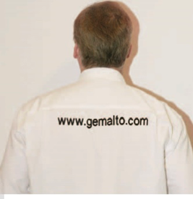
Promoting Mobile Payment with Gemalto

Like the promotion of 3G phones, Gemalto's mobile payment requires special phones, special SIM cards, and custom orders from mobile service providers. Additionally, support from major banks and China UnionPay is crucial due to the linkage with personal accounts. China Mobile’s "mobile wallet" attempted to integrate the antenna directly into the SIM card, bypassing the need for specially designed phones, but to enable a secure enclave on a uSIM card for insertion into a Smartphone requires cooperation from Smartcard manufacturers.
Online Commerce: From Taiwan to Mainland China ( Q&A Session)
**Reporter:** Did you encounter any challenges transitioning from Taiwan to Mainland China back in 1992?
**Karl:** Yes! I originally learned traditional Chinese characters, so I couldn't read or write simplified characters initially, and had to relearn everything, but it became easy after that. But I still enjoy writing in traditional characters because they look beautiful.
**Reporter:** Is Chongqing the pilot city for the mobile payment system in China?
**Karl:** Yes, many people don’t know that in 2007, we were the first to pilot a Contactless mobile NFC payment system in Chongqing in partnership with China Mobile. However, China Mobile later took a different path. For me, this was a fierce competition between international standards and growing localized non-international standards. Even Gemalto wasn’t fully aware of this evolving situation. So about four or five months ago, I adjusted my strategy to overcome the Greater Firewall of China by delivering public speaking and uploading content on local Chinese streaming media websites, like Youku. Through my public speaking presentations, I helped mobile operators, OEM phone manufacturers, and banks/financial institutions to establish mutual trust and cooperation to grow the ecosystem.
**Reporter:** What are the main challenges in your work?
**Karl:** The toughest part is persuading OEM phone manufacturers to invest in developing an embedded design for these phones based on our uSIM smartcard technology. Carriers don’t want to do this as they feel it lowers their status. Banks didn’t wish to spend resources on this because they didn’t see immediate profits. So who should do it? I realized to do my job, it was up to me to evangelize this technology through my speeches, to persuade phone manufacturers to work on these design-in projects. They need to add an NFC chip to the phones (from NXP), and use the Gemalto uSIM cards, adopting an international SWP (single wire protocol), which Gemalto developed and offers for free to phone manufacturers.
**Reporter:** How is the phone development progressing now?
**Karl:** ZTE has developed several models that are about to go into mass production, and We have had success with HTC in Taiwan. Other domestic brands are also in the process of development. The key is that we use mature international standard technology, saving on the cost of developing new standards. Once the number of phones reaches a certain level, carriers can start adopting them.
**Reporter:** Do you also give speeches on mobile payment security?
**Karl:** Yes, Gemalto acquired a company called Trusted Logic(later spun out into Trustonic) that develops embedded mobile payment wallet security software in chip. Since I am more familiar with the local situation, I am fully responsible for this additional task from our sister company. Once mobile payment becomes widespread, and personal accounts are linked to mobile accounts, security will naturally become a critical issue.
**Reporter:** Besides the topics we’ve discussed, do you offer other interesting subjects in your speeches?
**Karl:** Since my early twenties, I have worked in Greater China. When I returned to the U.S. in 1992, I found that Americans knew little about Greater China’s future or how to interact with Chinese people. So I started giving speeches on “How to Do Business with Chinese People.” I was also invited to and offered a course at a hutong school in Beijing for Europeans on “How to Develop a Career in China.” I am eager to share what I know with Americans. As a real treat, I was invited to deliver a class on ShanZhaiJi (Mountain Bandit) feature phones back in 2009 to an MBA class at Peking University (invited by a Professor).
**Reporter:** Zhang Feng / **Text:** Liu Li-Jie / **Photography:** A translation from the original in China Financial Commerce Magazine of October 2010

October 2010

